# CS 255 System Design Document Template

## UML Diagrams

### UML Use Case Diagram

### UML Activity Diagrams

*Activity: Student Login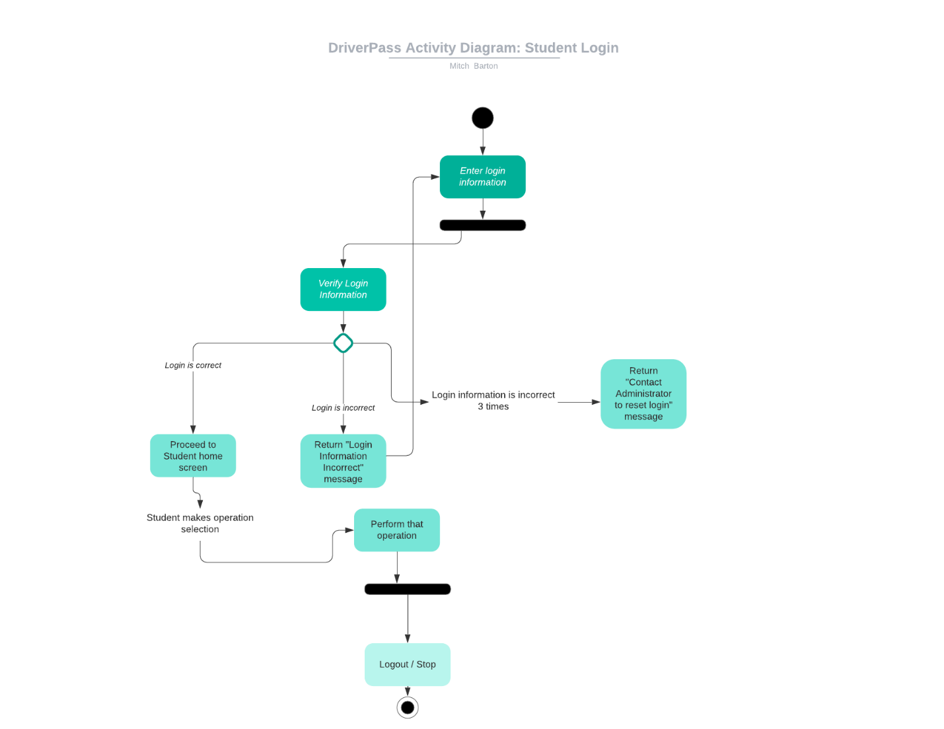*

*Activity: Student choosing instruction package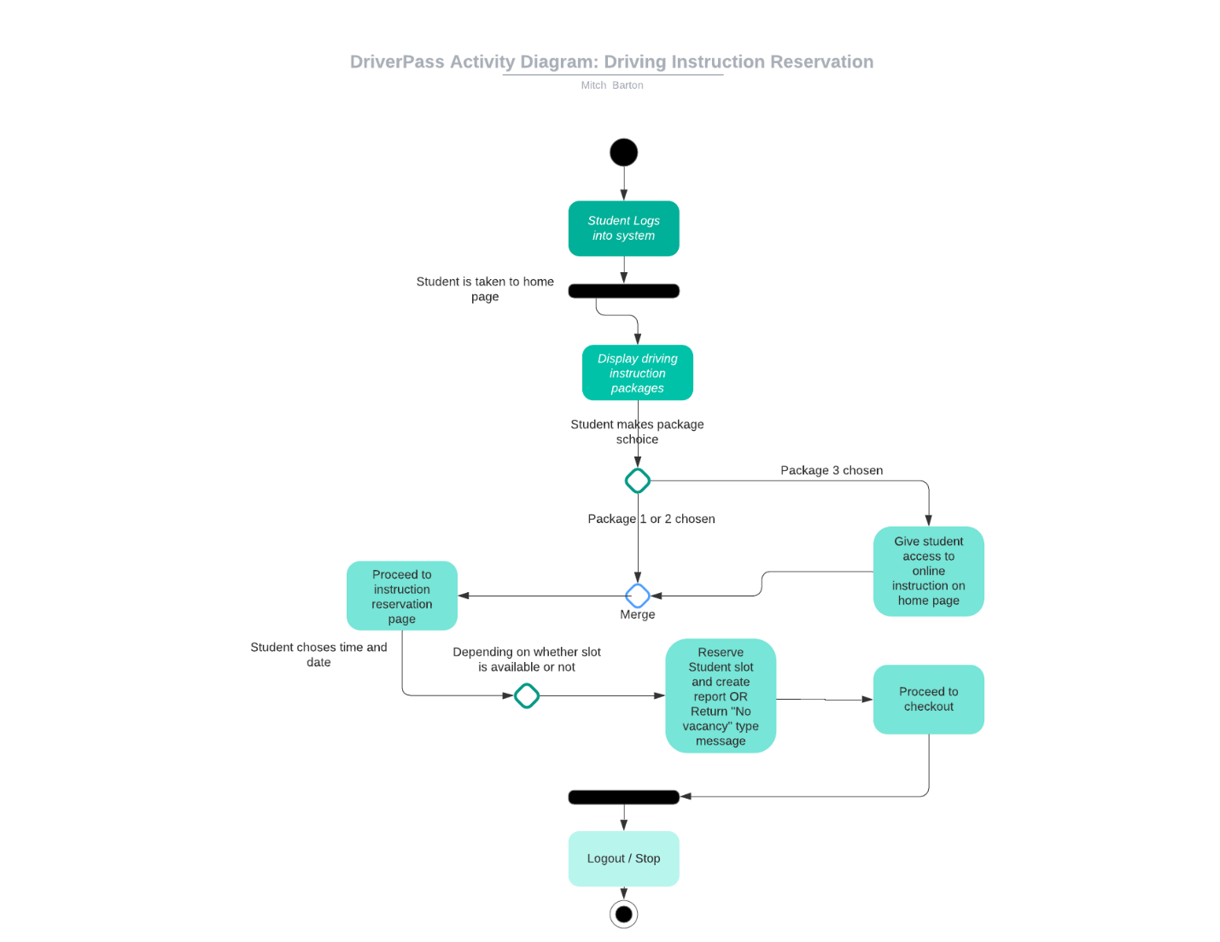*

### UML Sequence Diagram

### UML Class Diagram

## Technical Requirements

The technical requirements of the DriverPass system should carefully account for hardware, software, tool, and infrastructure considerations. The company is aiming to expand their business opportunities by utilizing a web-based application for driving instruction. The basic hardware requirements for this system would be users with an online-enabled electronic device that uses an operating system (Windows, MacOS, iOS, Android, Unix, etc.). Since the company is relatively small, the infrastructure is not present for on-sight database storage; this where cloud storage comes in. With the system needing to work across multiple platforms, the use of the database MongoDB, scaling to include any new processes should be a relatively easy task (if built properly) due to sharding of data zones by MongoDB (MongoDB 2020). The access of user information and reports should be extremely fast; a SQL based database is optimal for storing and accessing small data types. Currently one of the most popular tools for building cross-platform applications is React Native. Modules can be written in a variety of languages (C, Swift, and Java), while the main framework uses JavaScript. This will allow ease of integration with any other API calls (to the DMV database for updates), and conversion from source code to native elements takes less time than other frameworks.

Works Cited:

MongoDB, INC. 2020. “Introduction to MongoDB”. https://docs.mongodb.com/manual/introduction/